**C# HANDSON 4**

**NAME – ASHI JAIN**

**BATCH – IBM .NET**

**Q) Implement a real – life example on abstraction, function overloading, function overriding.**

A)

1. **Abstraction**

**CODE ->**

using System;

using System.Collections.Generic;

using System.Linq;

using System.Text;

using System.Threading.Tasks;

namespace AbstractDemo

{

public abstract class OnePlus

{

public void PhoneCall()

{

Console.WriteLine("Phone call common feature");

}

public void PhoneMessage()

{

Console.WriteLine("Phone message common feature");

}

public abstract void PhoneModel();

public abstract void PhoneColor();

}

public class OnePlus9Pro : OnePlus

{

public override void PhoneModel()

{

Console.WriteLine("Model: One Plus 9 Pro");

}

public override void PhoneColor()

{

Console.WriteLine("Color: White");

}

}

public class OnePlus9 : OnePlus

{

public override void PhoneModel()

{

Console.WriteLine("Model: One Plus 9");

}

public override void PhoneColor()

{

Console.WriteLine("Color: Black");

}

}

internal class Program

{

static void Main(string[] args)

{

OnePlus9Pro onePlus9Pro = new OnePlus9Pro();

Console.WriteLine("##############################");

onePlus9Pro.PhoneModel();

onePlus9Pro.PhoneCall();

onePlus9Pro.PhoneMessage();

onePlus9Pro.PhoneColor();

Console.WriteLine("##############################");

OnePlus9 onePlus9 = new OnePlus9();

onePlus9.PhoneModel();

onePlus9.PhoneCall();

onePlus9.PhoneMessage();

onePlus9.PhoneColor();

Console.WriteLine("##############################");

Console.ReadLine();

}

}

}

**OUTPUT 2 ->**

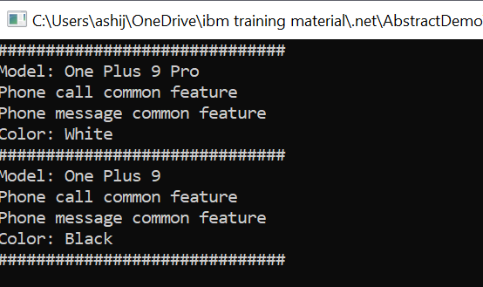

1. **Function Overloading**

using System;

using System.Collections.Generic;

using System.Linq;

using System.Text;

using System.Threading.Tasks;

namespace FunctionOverloadingDemo

{

public class Login

{

public void LoginCredentials(int StudentId, int pin)

{

if(StudentId == 8082 && pin==1234)

{

Console.WriteLine("The student has logged in succesfully");

}

else

{

Console.WriteLine("Invalid student id or pin");

}

}

public void LoginCredentials(int FacultyId, int pin, string Role)

{

if (FacultyId == 121 && pin == 4567 && Role == "AI Faculty")

{

Console.WriteLine(" Faculty has logged in succesfully");

}

else

{

Console.WriteLine("Invalid faculty id or pin");

}

}

}

internal class Program

{

static void Main(string[] args)

{

Login login = new Login();

login.LoginCredentials(8082, 1234);

login.LoginCredentials(121, 4567, "AI Faculty");

}

}

}

**OUTPUT ->**

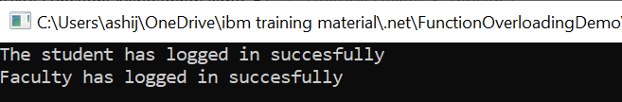

1. **Function Overriding**

using System;

using System.Collections.Generic;

using System.Linq;

using System.Text;

using System.Threading.Tasks;

namespace FunctionOverridingDemo

{

internal class Program

{

public class Student1

{

public virtual void StudentName()

{

Console.WriteLine("Student name: Ashi");

}

}

public class Student2:Student1

{

public override void StudentName()

{

Console.WriteLine("Student name: Riya");

}

}

static void Main(string[] args)

{

Student2 student2 = new Student2();

student2.StudentName();

Console.ReadLine();

}

}

}

**OUTPUT ->**

